**Noname manuscript No.**

(will be inserted by the editor)

**Bootstrapping for Fuzzy Mediation and Moderated-Mediation Analysis**

**Da Jeong Kang1,†· Hyeon Gu Kang1,†· Sung Wook Baik3 · and Jin Hee Yoon\***

Received: date / Accepted: date

**Abstract**

Mediation analysis is a statistical method that tests hypotheses about how the independent variable X affects the dependent variable Y, with a focus on analyzing the mediating effect that is transmitted through the mediator. Mediation analysis is widely used in various fields such as psychology, education, and business. Traditional methods for testing mediation effects include Baron and Kenny's stepwise approach, Sobel's method, and more recently, bootstrapping. However, while previous research on mediation analysis conveys linguistic meaning, even ambiguous data is represented as precise numerical data, making it difficult to handle. Fuzzy numbers such as soft numbers may be more appropriate for representing this type of ambiguous data. While Yoon has conducted research on fuzzy mediation analysis, he unfortunately used the traditional Sobel method, which assumes that the sample distribution follows a normal distribution, making it difficult to analyze biased distributions. Therefore, we propose conducting fuzzy analysis on various models using the statistical method of bootstrapping, which forms an empirical distribution using sample data to estimate the sample distribution when the sample distribution is unknown. We used the PROCESS MACRO for R to estimate the regression coefficients of each model using bootstrapping and compared the confidence intervals for indirect effects with the traditional Sobel method.

**Keywords:**

1 Department of Mathematics and Statistics, Sejong University, Seoul 05006, South Korea ; {doramisister, mjsk1145}@naver.com

3 Department of Software, Sejong University, Seoul 05006,

Korea;[sbaik@sejong.ac.kr](mailto:sbaik@sejong.ac.kr)

**\***Correspondence: [jin9135@sejong.ac.kr](mailto:jin9135@sejong.ac.kr); Tel.: +82-10-9118-3135

**†** These two authors contributed equally to this work

# 1 Introduction

When describing human behavior, social scientists and behavioral scientists hold that when people are exposed to particular stimuli, they do not instantly react but rather do so through internal organic body.  We have been curious in the process by which one phenomenon influences another because of this. By adding a third variable, they attempted to investigate the causal relationship between the independent and dependent variables and better comprehend their relationship, and it was discovered that the mediator and moderator components of this variable are separated.

A mediator variable is a variable that logically intervenes between independent and dependent variables in the causal relationship and is required to explain why or how.

For instance, client satisfaction will increase as a result of a company's satisfied products. In other words, consumers who are happy with the product will also be satisfied with the company; on the other hand, customers who are unhappy with the product will typically be less satisfied. The variable that describes how this relationship impacts is the mediator variable in this instance where there is a static correlation between product satisfaction and customer satisfaction. In this relationship, it may be inferred that as consumer trust in the the product's manufacturer increases, so does the positive correlation between product satisfaction and customer satisfaction. The purpose of the mediation effect study is to identify a variable that may more effectively explain the relationship that exists in the middle by determining if there is a meaningful influence between these two variables. A moderator variable is a variable that influences the amount and direction of the relationship between independent and dependent variables. The purpose of a moderation effect study is to determine how moderator factors affect the intensity or direction of the relationship between independent and dependent variables. The purpose is to determine if, and under what circumstances, when, or from whom, the relationship between the two variables is weaker or stronger. Researchers in several fields have researched this mediation impact and moderation effect. [] Additionally, studies have been conducted in the past to confirm the relevance of combining mediation effects and moderation effects for qualitative comprehension between variables. [] One example of this is the moderated mediation effect, which will be discussed in this article. The term "moderated mediation effect," was first introduced in 1984 by James & Bret [], refers to the regulation of a particular variable or the intensity of the mediation effect. In other words, the mediation effect is either reinforced or diminished as the value of the moderator variable increases (Jame & Bret, 1984). In Fig. 1, the mediation effect, moderation effect, and moderated mediation effect are represented as a simple model.

The regression-based assessment techniques developed by Sobel (1982), Baron and Kenny (1986), and Aroian and Goodman test methods have all been extensively utilized in recent thesis to conduct mediation analyses. However, the examination of the mediation effect using Baron and Kenny (1986) only establishes if the mediation effect exists or not; it does not establish its statistical significance. Furthermore, in the analytical sequence and judgment process in the case of statistical significance of the mediation effect, the other Sobel, Aroian, and Goodman methodes are not simple , and these methodes have weak statistical power and do not account for measurement mistakes in the study model. The method employing bootstrap has lately been utilized in several studies as a way to address this since it is thought to have limitations in terms of confirming the mediation model and that it is not accurate.

In the meantime, the study of these mediation models was carried out using "precise numbers." However, there are certain statistics that are difficult to convey with precise numbers in reality because they contain ambiguous phrasing. It is simple to communicate language connotations like "some" and "moderate," but it might be challenging to work with precise numerical data. Particularly in the area of social science that deals with psychology, we often come across such ambiguous facts, and in trying to describe them in exact figures, we not only risk losing knowledge but also run into issues. It is true that a precise number cannot accurately capture a person's mental aspect, for instance, when a person's degree of stress is assessed as a variable. Additionally, even though this is stated numerically, each person's assessment scale is unique, so even if the data value is the same, it could really be a different value. As a result, if it is coded as it is, information loss is unavoidable. As a result, it makes sense to describe it as a soft number, like the fuzzy number that Zadeh initially proposed.

Yoon carried out a mediation study based on fuzzy theory in 2020 []. However, there has been no research done on the bootstrap paper using fuzzy mediation and fuzzy moderated-mediation. Bootstrap has been prevalently cited as a method for verifying the mediating effect. However, the Baron & Kenny method, an inaccurate statistical method with errors in statistical inference, and the sampling distribution, which shows the biased distribution with the assumption that the sampling distribution forms the normal distribution, are the alternatives to Sobel’s method, which encounters the criticism for not being able to verify statistically significant mediating effects. However, it is a beneficial method with strengths in that it does not require any assumptions for the variable and sampling distribution.)

In example, the bootstrap method, which requires millions of resampling operations, has been more popular lately as access has become simpler and computer speed has increased through the statistical software like AMOS. Therefore, in this study, we suggest utilizing the bootstrapping method to examine the fuzzy mediation model and the fuzzy moderated mediation model.

This paper is structured as follows: Sect. 2 introduces the existing statistical test method and the bootstrap method to be used in this paper, Sect. 3 proposed fuzzy mediation and moderated - mediation models, and Sect. 4 provides an estimation method using bootstrap using the various models proposed in Sect. 2. In Sect. 5, data analysis is provided along with the data set using the model and estimation method described above, and the results are concluded in Sect. 4.

**2. Fuzzy Mediation and Moderated-Mediation Analysis**

**2.1 Existing Mediation Effect Test Method**

**2.1.1 Baron & Kenny**

Baron & Kenny’s (1986) research has made a clear definition of mediating effect and controlling factors and explained the logic of verification on mediating effect readily intelligibly and intuitively. It is the most widely cited method in the papers as a testing method of the mediating effect by verifying how the mediating effect can be proven.

The method has recently encountered criticisms due to a bevy of problems. When estimating the size of the mediating effect, the conclusion on the mediating effect has been made indirectly by verifying with different figures in order not by verifying from the statistical reasoning to determine if the size has a significant meaning. An error can occur at in anytime, especially when examining a hypothesis. The probability of an error is inevitably getting higher as the number of hypotheses to be proven increases simultaneously. Hence, it has turned out that the reliability of the testing is weak due to excessive errors that occurred from the sequential testing of multiple hypotheses (e.g., Fritz & MacKinnon, 2007; Hayes & Schaarkow, 2013). In addition, it is widely known that Baron & Kenny’s testing method analyzes the mediating effect based on the assumption that the effect of independent variables on the dependent variables should be statistically significant. However, it is not valid. The verification method of the mediating effect is under the criticism that it is not an accurate statistical method rather than it is not statistically close.

**2.1.2 Sobel Test**

The core problem of Baron & Kenny’s verification method occurs indirectly in the verification process of mediating effect. Sabel’s (1982) method can be considered an advanced approach in that the method calculates the magnitude of the effect directly. Researchers frequently cite the Sobel test since the method can be utilized comparatively simply than other methods in verifying the mediating effect. However, it is found that there are defects in Sobel’s verification method. When verifying the significance of the mediating effect with Sobel’s testing method, the assumption is that the sample distribution of the value forms the normal distribution. Unlike the assumption, however, the sampling distribution used widely by most researchers in mediating effect verification is mostly deflective, not showing the normal distribution (Bollen & Stein, 1990; Shrout & Bolger, 2002). Therefore, it can be deduced that Sobel’s method has limitation in telling the statistical significance of mediating effect (Fritz & MacKinnon, 2007; Hayes & Scharkow, 2013).

**2.2 Bootstrapping**

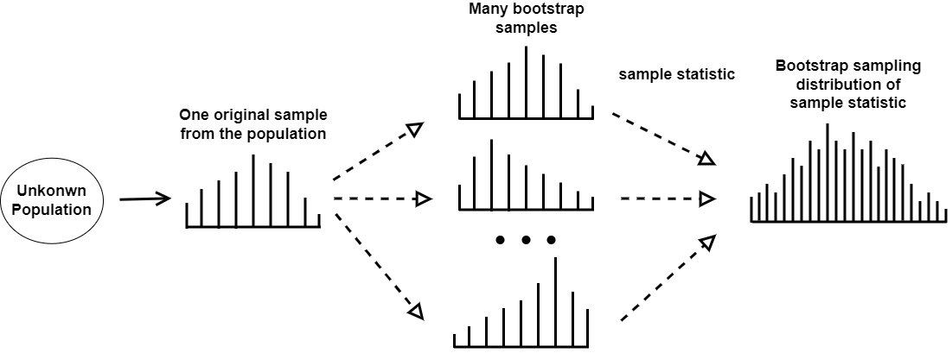Generally, the confidence interval of the mediating effect has been calculated based on the assumption that the sampling distribution follows the normal distribution or a t distribution. However, the cases where the extracted samples do not follow a normal or t distribution are found. If the confidence interval is calculated with a normal distribution or a t distribution when the sampling distributions are not symmetrical, it can provide an approximation of the correct confidence interval. However, it cannot always provide a reliable approximate value as always. As an alternative to the weakness of the method, the bootstrapping method has recently become pervasive for researchers.

The bootstrapping method is a statistical method that estimates the sample distribution based on the empirical distribution utilizing sample data while the sample distribution is not informed. Namely, given the fact that the method can calculate the approximate standard error, confidence interval, and significance probability of the estimated sample distribution by repeatedly projecting after extracting and restoring the same-sized sample randomly without making any assumptions on the distribution of variables or sample distribution (Figure 0)

Two methods have been suggested for verifying the mediating effect with bootstrapping. First, one is to determine whether zero is included in the confidence interval of the re-extracted sample distribution, and the second is to identify the effect with the significant probability of total indirect effect through the decomposition of testing mediating method. The specific methods that calculate the confidence interval can be categorized into Percentile and Bias-corrected.

The method to examine the mediating effect by utilizing the bootstrapping method has been introduced by several scholars since the 1990s (Bolen & Stein, 1990). Despite the strengths the method has, the reason why the bootstrapping method has not been widely accepted was derived from the difficulty in executing a considerable amount of calculation without using a computer, and there were inevitable limitations in application due to its complexity in programming. However, along with the significant advancement in computer development and the simplified procedures in using bootstrapping through the various statistic packages, the utilization ratio of the method is getting higher in different academic fields. Therefore, in this paper, the statistical significance of the fuzzy mediation model was explained using bootstrap.

**Fig 1** Distribution estimation using bootstrap

**2.2.1 Percentile bootstrap**

When the magnitude of the influence of the independent variable on the parameter is set as a, and the magnitude of the effect of the parameter on the dependent variable, controlling the influence of the independent variable, is set as b, the indirect effect can be defined as ab. Among the reasoning methods that do not require assumptions on the sampling distribution of ab that refers to the magnitude of the indirect effect, there is a typical method that test the indirect effect by utilizing the confidence interval of a bootstrap. One of the procedures to set the confidence interval (95%) by the percentile bootstrap method is as follows (Shrout & Bolger 2002). All procedures are automatically carried out in PROCESS macro, a computer program developed by Hayes.

Reinforcement is extracted from the original sample with sample size N extracted from the population, and a bootstrap sample with the same size N as the original sample is extracted.

1. Using the bootstrap sample obtained in step 1, estimate the statistics of indirect effects in the resampling.
2. Repeat steps 1 and 2 k times to generate k bootstrap samples and estimate and store k indirect effects using them.
3. Sort the k indirect effect estimates from lowest to highest.
4. In the case of using a 95% confidence interval, the lower limit is defined as the statistic value corresponding to the 0.5th (100-95)th percentile of the distribution of the previously obtained statistic value. The upper bound is defined as the statistic corresponding to the [100-0.5 (100-95)]th percentile from the distribution of k statistics arranged in ascending order. The lower and upper bound values are determined as the endpoints of the 95% confidence interval.

If 0 is not included in this 95% confidence interval, the indirect effect is said to be statistically significant.

**2.2.2 Bias-corrected bootstrap**

A bias-corrected bootstrap compliments the potential bias in percentile bootstrap confidence intervals was suggested by Efron and Tibshirani (1986). The Bias-corrected approach shares the same grounds with the percentile confidence interval. However, it is different from the percentile bootstrap confidence interval in that the bias constant is calculated by utilizing the ratio of the point numbers more minor than the point estimate value of the indirect effect of the original sample among the k indirect effect estimates calculated from the k bootstrap samples. It is a revised confidence interval that equals the error rates of both ends of the percentile bootstrap confidence interval. It determines the upper and lower bounds of the confidence interval by closely reflecting the asymmetry of the bootstrap estimate distribution. Therefore, when the sampling distribution of the estimate is not symmetrical, the Bias-corrected method is more suitable for obtaining more accurate results. However, recently, several reports have mentioned that bias-corrected bootstrapping may not be a proper testing method since it causes type I error despite its high proving capability (Biesanz et al.,2010, Hayes & Scharkow, 2013, Falk & Biesanz, 2015, Tofighi & Kelly, 2020).

**3. Fuzzy Mediation and Moderated-Mediation Analysis**

In this section, referring to the basic concepts in [1], we introduce the definition of fuzzy numbers by Zadeh [2], and simple fuzzy mediation models with mediators and fuzzy moderated-mediation model introduced by Yoon [3,4].

**3.1 Fuzzy number**

The definition of a fuzzy number in real numbers R, which implies when normalized and convex, is a fuzzy set. An element of a fuzzy set is one that accepts a real value between -1 and 1 as a measure of belonging according to a function known as the membership function. There are no standard rules since the membership function's form might be described in terms of either objective or subjective possibilities. As a result, the LR-fuzzy numbers parametric class of fuzzy numbers is used in this particular situation. A fuzzy number A is referred to be an LR fuzzy number if it meets the conditions listed below.

where L and R are reference functions called left and right shape functions of X and have the following properties : L,R :R→[0,1] are left-continuous and decreasing function with R(0) = L(0) = 1, R(1) = L(1) = 0. And ‘m’ means the mode of the LR-fuzzy number A. ‘l’ and ‘r’ are greater than 0 and mean the width of the left and right sides. We abbreviate the LR-fuzzy number as . And LR-fuzzy number, one of the triangular numbers, has the following two operations.

= (,

.

**3.2 Simple Fuzzy Mediation Model**

Through simple regression analysis, the Baron and Kenny's Simple Mediation Model's mediation analysis method analyzes the causal relationship step-by-step through. A statistical technique called mediation analysis explores ideas on how a causal antecedent variable (X) influences an outcome variable (Y). We suggest the following derivation of the three regression equations of Baron and Kenny: regression between independent variables and dependent variables, regression between independent variables and mediators, and regression between mediators and dependent variables.

The regression constants and are significant in this model. Here, X's estimated "direct effect" on Y is represented by the number "", while X's estimated "indirect effect" on Y through M is represented by the number " " and the number " ", which is the product of the two. Additionally, X's direct and indirect effects are added together to get , which is known as the "total effect" and equal to . It demonstrates that the direct effect () is less significant than the total effect (.

It makes more sense to describe ambiguous concepts as variables with fuzzy numbers than crisp numbers, such as "more," "less," and "happy." The following is the suggested fuzzy mediation model.

In the model as above, is the total effect, is the indirect effect, and is the direct effect. Note that it is easily checked that

**Fig 2** The simple fuzzy mediation model

**3.3 Fuzzy Mediation Model for Multiple Mediators**

It is often advisable to utilize a basic fuzzy mediation for various mediators rather than a simple fuzzy mediation model since the real world is much more complicated and multi-causal.

The following is a simple fuzzy mediation model with parameters k (k>1).

where

In the model as above, is the total effect, is the indirect effect through and on , and is the direct effect. In other words, there are k indirect effects.

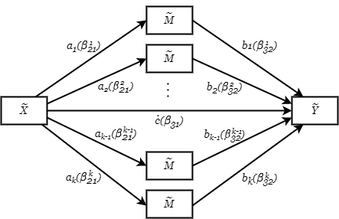

**Fig 3** The fuzzy mediation model with multiple mediators

**3.4 Fuzzy Moderated-Mediation Model**

**3.4.1 Moderated-Mediation Model**

Moderated-mediation is the mechanism by which the moderating variable (W), the fourth variable in the causal relationship, may adjust the indirect effect from the independent variable (X) to the dependent variable (Y) through the parameter (M). The terms "Adjusted mediating effect" and "conditional indirect effect" are presently used interchangeably and have the same meaning in statistics. (Preacher, Rucker & Hayes, 2007)

Understanding the conditional character of the mechanism by which one variable effect another variable and testing hypotheses about these conditional effects are the purpose of conditional process analysis, which combines conditioning analysis with mediation analysis. As a result, if the direct and indirect effects of the independent variable (X), which is important in the moderation analysis, are calculated and the influence of the independent variable (X) on the parameter (M), which is organized by the moderating variable (W), then X is not a single number but the effect on M is a function of W.

**3.4.2 Fuzzy Moderated-Mediation Model**

Let's say is a fuzzy predictor variable, is a fuzzy response variable, is a fuzzy mediator, and is a fuzzy moderator in a causal relationship involving ambiguous variables. The model shown in the Fig. below is a moderated mediation model, in which controls the route from to but does not influence any other pathways.

Because controls it, the direct eﬀect of is dependent on . Fig. 1 expresses the following model.

=,

.

Here, is defined as a function of = and represents the "fuzzy conditional effect" of in . Within this model, the indirect effect is defined as the product of a and b, identical to the simple fuzzy mediation model. The indirect effect in this model is deemed unconditional, as no moderation is imposed upon the or path. Therefore, in this model, indirectly affects through and also directly affects while depending on .

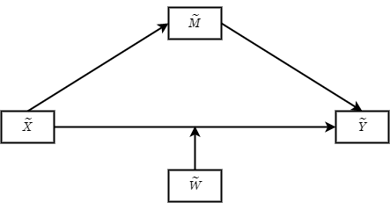

(a) Conceptual diagram

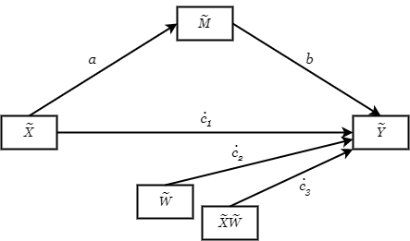

(b) Statistical diagram

**Fig 4** Moderated-mediation analysis for conditional direct dffect

Yoon [3,4] has so far put up a number of fuzzy mediation models . However, no study has used bootstrapping to evaluate this fuzzy model. The initial proposals for bootstrapping-based analysis of parameters are made in Chapter 4 for simple fuzzy parameter analysis and chapter 5's proposals are for analyses of different data types and climatic data.

**4. Bootstrapping for Fuzzy Mediation and Moderated-Mediation Analysis**

**4.1 Estimation for Fuzzy Mediation and Moderated-Mediation Analysis**

When using least squares estimation with fuzzy data, it is necessary to have a suitable metric in the fuzzy set spaces. A helpful type of metric can be established through the use of support functions. The support function of any compact, convex set can be represented as which is determined by the following formula for all :

where is the (d-1)-dimensional unit sphere in and represents the scalar product in . It should be noted that for compact and convex sets the support function is uniquely defined. A metric in a fuzzy number set is established through the use of the *-* metric in the space of Lebesgue integrable functions, represented as:

This leads to the definition of an *-* metric for fuzzy numbers as:

A fuzzy regression model was previously introduced in the author's studies [24,25] and is expressed as follows:

.

The variables are represented by and for It is assumed that are the fuzzy random errors that account for the fuzziness. It is worth mentioning that all cases can be covered by defining and as follows:

where represent the left and right spreads of respectively.

The estimators are obtained by minimizing the following objective function:

where *q* is the number of the regression model in this fuzzy mediation analysis and *k=1,2,…,q*,. The objective function is based on the *-*metric, and the *-* distance can be calculated as:

To minimize the above equation, we obtain the normal equation applying

The normal equation has as its solution, and for each value of , the normal equation can be written as follows:

To determine the solution vector, we introduce a *triangular fuzzy matrix* *(t.f.m.)* which is expressed as

,

and abbreviated as , where is a triangular fuzzy number forandAdditionally, we define a triangular fuzzy vector

.

To minimize the objective function mentioned above, we apply the fuzzy operations, fuzzy numbers and estimators defined in our previous studies [26-29]. The fuzzy operations are as follows:

*.*

The following operations are defined for two triangular fuzzy matrices, , , and a crisp matrix :

,

*,*

*,* .

.

The solutions to the normal equation fuzzy estimators are derived for each by using the above operations and algebraic properties, with

where

and , for Note that the solution (16) exists only if .

**4.2 Statistical inferences of Fuzzy Mediation Model and Moderated-Mediation Analysis**

**4.2.1 Interval Estimation Using Existing Method**

The assumption that Fuzzy least squares estimators follows a normal distribution asymptotically is well-known from previous research. When the population variance is unknown, the t-distribution is applied, and when the sample size is large, it is assumed that the data follows a normal distribution, and the (1-α)100% confidence interval for the total effect and direct effect can be represented using the z-value.

*CI for the total effect :*

*CI for the direct effect*

The standard error, *se* of the direct effect and total effect is defined as follows.

For the sample mean, the following property can be applied.

*,* where is a fuzzy random variable.

In addition, hypothesis tests

,

.

For the indirect effect, the confidence interval can be inferred through the "Sobel test" or "delta method" or “product of coefficients method”. The indirect effect ab is an estimated value of based on the sample. The significance level of the indirect effect is determined by dividing the estimate of the mediating effect by the standard error of the estimate and using it as the test statistic to judge the normal distribution(Z).

where .( second order standard error estimator)

means the standard errors of a and b, respectively.

*CI for the indirect effect*

where .

Based on above assumptions, the hypothesis test

.

In the case of the Sobel test, the normality of the sample distribution of the indirect effect is assumed, and the standard normal distribution is used for derivation. Such assumptions are reasonable for large samples, but not for small samples. Assumptions that vary depending on the situation generally produce low test power. Nevertheless, many experts in various fields still use the Sobel test.

**4.2.2 Proposed Interval Estimation using Bootstrapping**

In this Section, we propose using the bootstrap and confidence intervals for statistical inference on the model proposed in Sect. 3.

Bootstrap was first proposed by Efron(1979) to overcome the limitations of mediating effect test methods that assume normality. Bootstrap is a non-parametric and empirical resampling method that does not require assumptions about the sampling distribution of the mediating effect estimate. In the previous section, we examined the classical approach to constructing confidence intervals. We propose a method of estimating confidence intervals by using the sample percentiles of the bootstrap distribution among various bootstrap methods.

A resample of size n is taken from the original sample, and the estimate is calculated for the resample. This is repeated several times to determine the dispersion of the resample estimates. A bootstrap sample , , , is obtained by resampling with replacement from the given probability distribution , *, ,,*. The desired statistic can be obtained for this bootstrap sample, and this is used to estimate the bootstrap distribution of the estimated statistic . To calculate an accurate estimate of the confidence interval, at least 1000 bootstrap samples are appropriate, and a larger value of B is better.

The percentile bootstrap method *PB* constructs the (1−α) × 100% confidence interval for , obtained by listing the estimated statistics {, , } through B bootstrap samples in ascending order ≤ ≤ · · · ≤ as follows.

[ , ]

Here, BL(Bootstrap Lower bound) is the average of the percentile of 은 and the next number, and BU(Bootstrap Upper bound) is the average of the percentile of and the previous number.

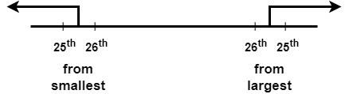

**Fig 5** Confidence interval estimation using bootstrap when

The (1-)100% confidence interval for the total

effect and the direct effect is expressed as follows.

*CI for the total effect* [ *,*

*CI for the direct effect* [ *,*

The standard error *se* of the direct effect and the total effect is defined as follows:

For the sample mean, the following property can be applied.

*,* where is a fuzzy random variable.

In addition, hypothesis tests

,

,

If the confidence interval of the indirect effect ab is defined through bootstrap,

*CI for the indirect effect*

The standard error *se* of the indirect effect is defined as:

The standard error of a, the influence of the path from to , is

The standard error of b, the influence of the path from to , is as follows :

We propose a 95% bootstrap confidence interval through 5000 iterations. Therefore, α=0.05, BL is the average of the 2.5th and 2.6th percentiles, which becomes the average of the estimated statistics at 125th and 126th, and BU is the average of the estimated statistics at 4,874th and 4,875th.

**5 Data Analysis**

**5.1 Fuzzy mediation Analysis for Team Performance Data**

The effect of dysfunctional behavior on team performance has been proposed by many authors [ ]. Also a mediation analysis using fuzzy data is also proposed in [ ]. The variable “Dysfunctional Behavior” (X) means how often team members act to weaken other team members or to hinder innovation or change. The variable “Team performance” (Y) means that the supervisor judges the efficiency of the team and its ability to get task done in a timely fashion. The variable “Negative tone” (M) means how often team members feel angry and disgust at work. As in the previous paper, all the variables are fuzzified with spread 0.05. The model is described in Fig. 수. The result of the fuzzy mediation model is as follows:

Here, Indirect effect is the product of the coefficient of and .

Indirect effect:

And the total effect is the sum of direct effect and indirect effect.

Total effect:

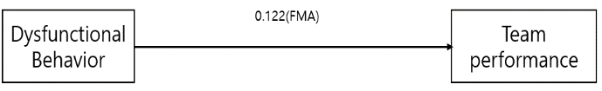

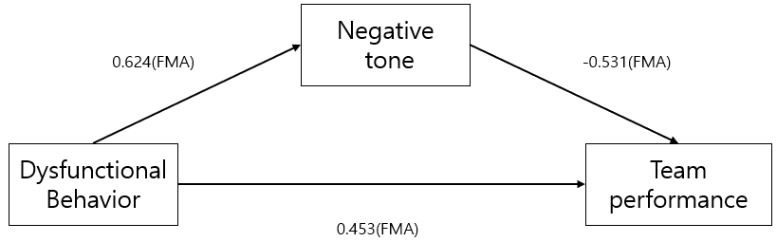

**Fig6** The fuzzy mediation analysis of the team performance data

**Table 수** Effects of the Dysfunctional behavior on team performance

|  |  |  |
| --- | --- | --- |
| Method | Effect |  |
|  | Total effect Direct effect | Indirect effect |
| FMA |  |  |

5.1.1 Statistical Inference on the Total, Direct and Indirect Effect

The effects of the Dysfunctional behavior on team performance are shown in Table . value is approximately the same as value when the degree of freedom is large enough.

i) For 95% confidence interval for the total effect in FMA,

95% CI for ,

where

For the hypothesis test: v.s. under the test statistic is,

ii) For 95% confidence interval for the direct effect in FMA,

95% CI for ,

where

For the hypothesis test: v.s. under the test statistic is,

iii) For 95% confidence interval for the indirect effect in FMA,

95% CI for ,

where

For the hypothesis test: v.s. under the test statistic is,

5.1.2 Bootstrap Confidence Interval on the Total, Direct and Indirect Effect

The bootstrap confidence interval was estimated using 5000 bootstrap samples.

i) For 95% bootstrap confidence interval for the total effect

The Bootstrap Sample Distribution is shown in Fig.

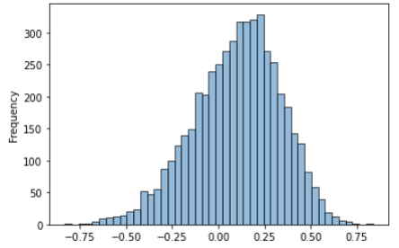

**Fig7** The Bootstrap Sample Distribution of the total effect

95% Bootstrap CI for

[ *, ,*

where

Additionally, and are obtained using continuity correction. is the average of the 2.5 percentile number and the next number.

In addition, is the average of the 97.5 percentile number and the previous number.

From the Table, CMA, FMA and bootstrap 95% confidence intervals are compared. In bootstrap, the total effect is significant because the confidence interval of bootstrap contains zero. On the other hand, the total effect of in CMA and FMA are not significant.

ii) For 95% bootstrap confidence interval for the direct effect

The Bootstrap Sample Distribution is shown in Fig.

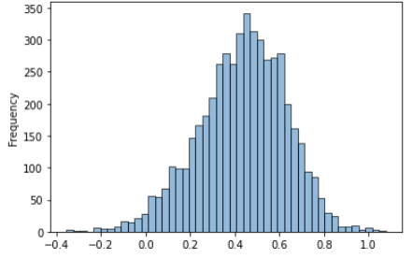

**Fig8** The Bootstrap Sample Distribution of the direct effect

95% Bootstrap CI for ,

where

Additionally, Like the previous method, is,

Also, is,

From the Table, we can see that direct effect of all methods is significant. However, the width of the confidence interval is smallest in Bootstrap.

iii) For 95% bootstrap confidence interval for the indirect effect

The Bootstrap Sample Distribution is shown in Fig.

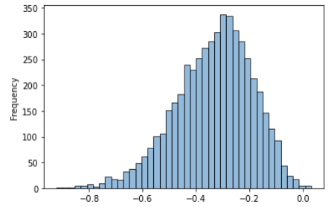

**Fig9** The Bootstrap Sample Distribution of the indirect effect

95% Bootstrap CI for ,

where

Additionally, is,

Also, is,

From the Table, we can see that indirect effect of all methods is significant. However, the width of the confidence interval is smallest in Bootstrap.

**Table** Confidence interval about total, direct and indirect effect of team data

|  |  |  |  |
| --- | --- | --- | --- |
| Effect | Method | 95% CI  lower bound | 95% CI  upper bound |
| Total | CMA  FMA  Bootstrap in FMA | -0.258  -0.042  0.088 | 0.479  0.284  0.163 |
| Direct | CMA  FMA  Bootstrap in FMA | 0.080  0.290  0.451 | 0.803  0.616  0.518 |
| Indirect | CMA  FMA  Bootstrap in FMA | -0.568  -0.500  -0.385 | -0.094  -0.162  -0.322 |

From the Table, we can see that the result of Bootstrap in FMA is the best way out of all the other methods. In other words, these results illustrate the need for Bootstrap in FMA. Since the confidence intervals of CMA and FMA do not contain zero, the result of total effect is not significant. However, In Bootstrap in FMA, the total effect is significant. This shows that without using bootstrap in FMA, we could get the biased conclusion. The width of the confidence interval is smaller in FMA than in CMA because FMA uses the fuzzy data. In additionally, the width of the confidence interval is smallest in Bootstrap in FMA. To reduce the width of the confidence interval while maintaining reliability, the number of samples must be increased. Thus, if we use Bootstrap method, we can save money and time because it takes more time and money to get more samples. Because of these points, it is most desirable to use the bootstrap method.

**5.2 Fuzzy mediation Analysis for Adolescent Hate speech data**

A study on the exposure of adolescents to hate speech was studied by []. For “Negative degree of hate speech”, was asked how they felt and acted when they were subjected to hate speech or discriminatory behavior. (1: strongly disagree, 5: strongly agree). The average score of 10 questions was used, and the higher the score, the greater the negative emotion when subjected to hate speech or discriminatory behavior, and the more contracted the behavior. For “Necessity of Response to hate speech” asked how much measures they thought were needed for hate/discrimination expressions. (1: not necessary at all, 5: very necessary). The average score of 7 questions was used, the higher the score, the higher the Necessity of Response to hate speech. For “Negative effect on social phenomena' asked how much he thought the problem of hate speech would expand to society and have a negative impact. (1: strongly disagree, 5: strongly agree). The average score of 9 questions was used, and the higher the score, the greater the degree to which the problem of hate speech have a negative effect on society. For “Seriousness of discrimination against minority groups” asked how serious the problem of hate speech and discrimination against minority groups (1: not serious at all; 5: very serious). The average score of 11 questions was used, the higher the score, the greater the degree to which the problem of hate speech and discrimination against minority groups is considered serious. All the variables of Adolescent Hate speech data are fuzzified with spread 0.5. The model is described in Fig 수. The result of the fuzzy dual mediation model is as follows.

Here, Indirect effect of the first mediator variable is the product of the coefficient of and .

Indirect effect:

Additionally, Indirect effect of the second mediator variable is the product of the coefficient of and .

Indirect effect:

And the total effect is the sum of direct effect and specific indirect effects.

Total effect:

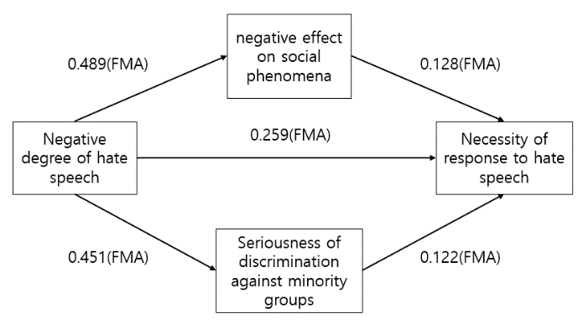

**Fig10** The fuzzy mediation analysis of the Adolescent Hate speech data

**Table 수** Effects of the Negative degree of hate speech on Necessity of response to hate speech

|  |  |  |  |  |  |  |
| --- | --- | --- | --- | --- | --- | --- |
| Method | | Effect | | |  | |
|  | Total effect | | Direct effect | Indirect effect1 | | Indirect effect2 |
| FMA | | | | | | |

5.2.1 Statistical Inference on specific indirect effects.

Here, standard error of the total effect in FMA is,

Additionally, standard error of the mediator variables is,

i) For 95% confidence interval for the indirect effect of the first mediator variable in FMA,

95% CI for ,

where

For the hypothesis test: v.s. under the test statistic is,

ii) For 95% confidence interval for the indirect effect of the first mediator variable in FMA,

95% CI for ,

where

For the hypothesis test: v.s. under the test statistic is,

5.2.2 Bootstrap Confidence Interval on specific indirect effects.

i) For 95% bootstrap confidence interval for the indirect effect of the first mediator variable

The Bootstrap Sample Distribution is shown in Fig.

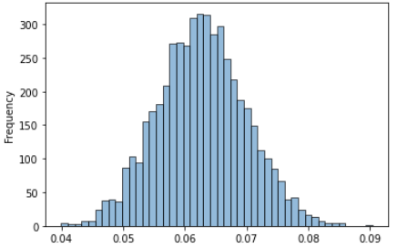

**Fig11** The Bootstrap Sample Distribution of the indirect effect

95% Bootstrap CI for ,

where

Additionally, Like the previous method, is,

Also, is,

From the Table, CMA, Bootstrap, FMA and Bootstrap in FMA 95% confidence intervals are compared. We can see that indirect effect of the first mediator variable is significant in all methods. However, the width of the confidence interval is smallest in Bootstrap in FMA.

ii) For 95% bootstrap confidence interval for the indirect effect of the second mediator variable

The Bootstrap Sample Distribution is shown in Fig.

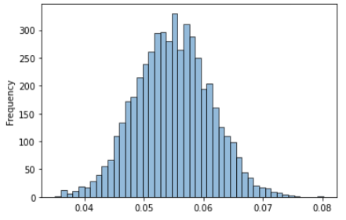

**Fig12** The Bootstrap Sample Distribution of the indirect effect

95% Bootstrap CI for

where

Additionally, is,

Also, is,

We can see that indirect effect of the second mediator variable is significant in all methods. However, the width of the confidence interval is smallest in Bootstrap in FMA.

**Table** Confidence intervals about specific indirect effects of Adolescent Hate speech data

|  |  |  |  |
| --- | --- | --- | --- |
| Effect | Method | 95% CI  lower bound | 95% CI  upper bound |
| Indirect1 | CMA  Bootstrap  FMA  Bootstrap in FMA | 0.0275  0.0259  0.0395  0.0624 | 0.0475  0.0495  0.0865  0.0639 |
| Indirect2 | CMA  Bootstrap  FMA  Bootstrap in FMA | 0.0165  0.0155  0.0354  0.0546 | 0.0350  0.0354  0.0746  0.0557 |

From the Table, we can conclude that the result of Bootstrap in FMA is the best way as the previous result.

**Acknowledgement** This work was supported by the National Research Foundation of Korea(NRF) grant funded by the Korea government(MSIT) (No. 2020R1A2C1A01011131; No. 2019M3F2A1073179).

**References**